# Materialized vs Non-Materialized Views

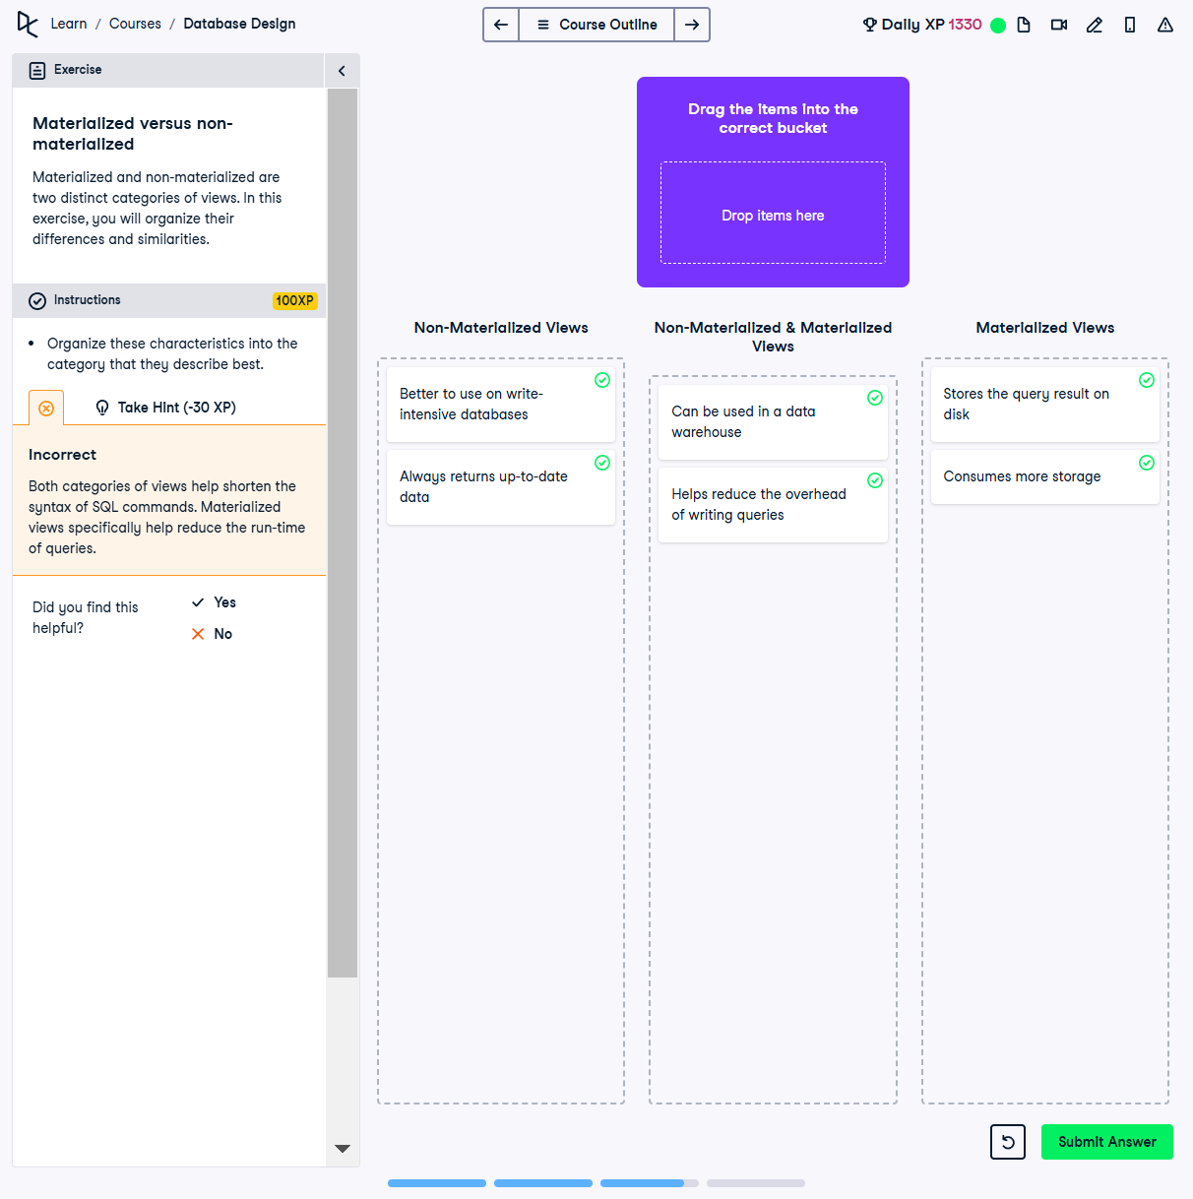

## Question:

Materialized and non-materialized views are distinct categories in SQL. In this exercise, we need to categorize characteristics that describe these views best.

## Categorization:

### Non-Materialized Views:

1. Better to use on write-intensive databases

2. Always returns up-to-date data

### Non-Materialized & Materialized Views:

1. Can be used in a data warehouse

2. Helps reduce the overhead of writing queries

### Materialized Views:

1. Stores the query result on disk

2. Consumes more storage

## Explanation:

Non-materialized views are dynamically generated upon query execution, ensuring fresh data but increasing query costs. Materialized views store query results persistently on disk, improving performance but consuming more storage. Both types help simplify query writing and can be used in data warehousing.